Data Types in Java

# Data Types in Java

Data types specify the different sizes and values that can be stored in the variable. There are two types of data types in Java:

1. **Primitive data types:** The primitive data types include boolean, char, byte, short, int, long, float and double.
2. **Non-primitive data types:** The non-primitive data types include [Classes](https://www.javatpoint.com/object-and-class-in-java), [Interfaces](https://www.javatpoint.com/interface-in-java), and [Arrays](https://www.javatpoint.com/array-in-java).

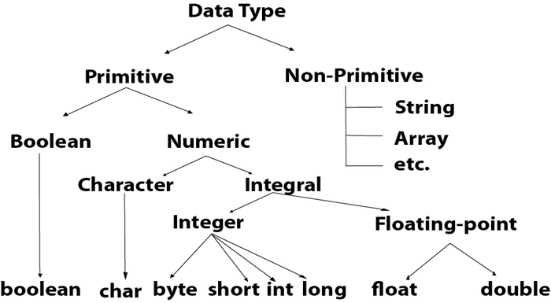

|  |  |  |
| --- | --- | --- |
| **Data Type** | **Default Value** | **Default size** |
| boolean | false | 1 bit |
| char | '\u0000' | 2 byte |
| byte | 0 | 1 byte |
| short | 0 | 2 byte |
| int | 0 | 4 byte |
| long | 0L | 8 byte |
| float | 0.0f | 4 byte |
| double | 0.0d | 8 byte |
|  |  |  |

## **Boolean Data Type**

The Boolean data type is used to store only two possible values: true and false. This data type is used for simple flags that track true/false conditions.

1. Boolean one = **false**

## **Byte Data Type**

The byte data type is an example of primitive data type. It isan 8-bit signed two's complement integer. Its value-range lies between -128 to 127 (inclusive). Its minimum value is -128 and maximum value is 127. Its default value is 0.

The byte data type is used to save memory in large arrays where the memory savings is most required. It saves space because a byte is 4 times smaller than an integer. It can also be used in place of "int" data type

**byte** a = 10, **byte** b = -20

## **Short Data Type**

The short data type is a 16-bit signed two's complement integer. Its value-range lies between -32,768 to 32,767 (inclusive). Its minimum value is -32,768 and maximum value is 32,767. Its default value is 0.

The short data type can also be used to save memory just like byte data type. A short data type is 2 times smaller than an integer.

# [Purpose of byte type in Java](https://stackoverflow.com/questions/16194681/purpose-of-byte-type-in-java)

Byte has a (signed) range from -128 to 127, where as int has a (also signed) range of −2,147,483,648 to 2,147,483,647.

What it means is that since the values you're going to use will always be between that range, by using the byte type you're telling anyone reading your code this value will be at most between -128 to 127 always without having to document about it.

Still, proper documentation is always key and you should only use it in the case specified for readability purposes, not as a replacement for documentation.

## **Int Data Type**

The int data type is a 32-bit signed two's complement integer. Its value-range lies between - 2,147,483,648 (-2^31) to 2,147,483,647 (2^31 -1) (inclusive). Its minimum value is - 2,147,483,648and maximum value is 2,147,483,647. Its default value is 0.

The int data type is generally used as a default data type for integral values unless if there is no problem about memory.

## **Long Data Type**

The long data type is a 64-bit two's complement integer. Its value-range lies between -9,223,372,036,854,775,808(-2^63) to 9,223,372,036,854,775,807(2^63 -1)(inclusive). Its minimum value is - 9,223,372,036,854,775,808and maximum value is 9,223,372,036,854,775,807. Its default value is 0. The long data type is used when you need a range of values more than those provided by int.

## **Float Data Type**

The float data type is a single-precision 32-bit IEEE 754 floating point.Its value range is unlimited. It is recommended to use a float (instead of double) if you need to save memory in large arrays of floating point numbers. The float data type should never be used for precise values, such as currency. Its default value is 0.0F.

**float** f1 = 234.5f

## **Double Data Type**

The double data type is a double-precision 64-bit IEEE 754 floating point. Its value range is unlimited. The double data type is generally used for decimal values just like float. The double data type also should never be used for precise values, such as currency. Its default value is 0.0d.

**Example:**

**double** d1 = 12.3

## **Char Data Type**

The char data type is a single 16-bit Unicode character. Its value-range lies between '\u0000' (or 0) to '\uffff' (or 65,535 inclusive).The char data type is used to store characters.

**char** letterA = 'A'

### **Why char uses 2 byte in java and what is \u0000 ?**

It is because java uses Unicode system not ASCII code system. The \u0000 is the lowest range of Unicode system. To get detail explanation about Unicode visit next page.

## **Java Operator Precedence**

|  |  |  |
| --- | --- | --- |
| **Operator Type** | **Category** | **Precedence** |
| Unary | postfix | expr++ expr-- |
| prefix | ++expr --expr +expr -expr ~ ! |
| Arithmetic | multiplicative | * / % |
| additive | + - |
| Shift | shift | << >> >>> |
| Relational | comparison | < > <= >= instanceof |
| equality | == != |
| Bitwise | bitwise AND | & |
| bitwise exclusive OR | ^ |
| bitwise inclusive OR | | |
| Logical | logical AND | && |
| logical OR | || |
| Ternary | ternary | ? : |
| Assignment | assignment | = += -= *= /= %= &= ^= |= <<= >>= >>>= |

### **Java Arithmetic Operators**

Java arithmetic operators are used to perform addition, subtraction, multiplication, and division. They act as basic mathematical operations.

### **Java Left Shift Operator**

The Java left shift operator << is used to shift all of the bits in a value to the left side of a specified number of times.

### **Java Right Shift Operator**

The Java right shift operator >> is used to move the value of the left operand to right by the number of bits specified by the right operand.

### **Java AND Operator Example: Logical && and Bitwise &**

The logical && operator doesn't check the second condition if the first condition is false. It checks the second condition only if the first one is true.

The bitwise & operator always checks both conditions whether first condition is true or false.

### **Java OR Operator Example: Logical || and Bitwise |**

The logical || operator doesn't check the second condition if the first condition is true. It checks the second condition only if the first one is false.

### **Java Ternary Operator**

Java Ternary operator is used as one line replacement for if-then-else statement and used a lot in Java programming. It is the only conditional operator which takes three operands.

### **Java Assignment Operator**

Java assignment operator is one of the most common operators. It is used to assign the value on its right to the operand on its left.